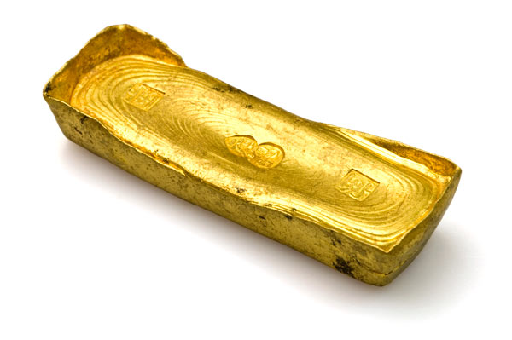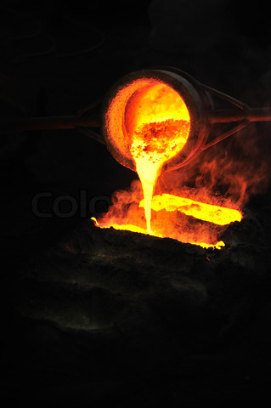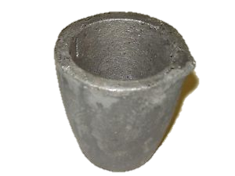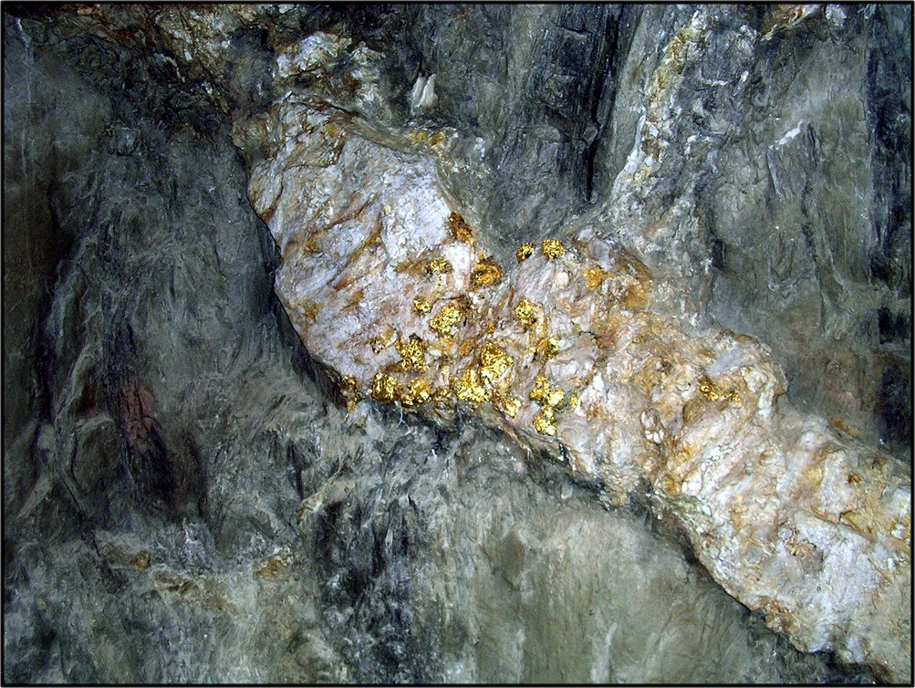

Ancient Ghana’s beginning is a mystery. Most believe is began in the 5th century B.C.E. Situated on the western coast of Africa, below the Sahara desert and above the forested regions of the south, Ghana was the trading empire. Its location gave to salt mines that, which they traded for gold to Morocco, Europe, and other African empires across the Sahara (trans-Saharan trade). The capital, Kumbi Saleh, was the main trading hub, and Ghana flourished for hundreds of years.

### The Golden Empire

## History of Ancient Ghana

## Works Cited

Call 1-800-TARDIS

Ancient Ghana

400 B.C.-1230 A.D.

Bella Rosi

Period 3

How to Smelt Gold

"Google Images." *Google Images*. N.p., n.d. Web. 12 Dec. 2013.

"How to Melt Gold." *WikiHow*. N.p., n.d. Web. 14 Dec. 2013.

"How to Mine For Gold." *Gold Rush Expeditions*. N.p., n.d. Web. 14 Dec. 2013

Team TARDIS

**Step Four: Pouring the Gold**

Using crucible tongs, take your crucible to you selected mold. You could make it an ingot, jewelry, perhaps weapons, or headpieces. Your mold should be made out of the same material as your crucible.

**Step Five: Letting it Cool**

Wait for your mold to cool COMPLETELY before handling it. Take it out of the mold and congratulations! You have smelted you own gold!

**Step Three: Use a Heat Source**

To begin melting, you will need to use a strong heat source. A forge or high fire, or perhaps just a blow torch. Sprinkle boric acid powder on the top of it and use the heat until the gold is completely liquid. For safety, wear goggles, do not wear loose clothing or anything flammable.

**Step Two: Place in Crucible**

To begin melting you need a crucible. A crucible is usually made of graphite or stone. Gold melts at 2000 degrees Fahrenheit, and the crucible needs to be made of something that wont melt before the gold does.

- Donec vehicula mauris in est

# Step One:

# Finding Gold

To began the smelting process, you first need gold. To find it naturally, you can mine for it. Gold will normally be found around iron ore deposits. You have to find the highest concentration of gold in one deposit and extract the gold as carefully as possible, using a crusher and a shaker. The n wash it to rid it of impurities. If you are not the mining type then you can simply use golden jewelry, or golden nuggets from your local markets and tradesmen.